* Structural business rules.
* A patient will have multiple New Patient communication details. Each New patient communication record is exactly for one patient.
* A Patient has One Medical Insurance Plan. Each medical insurance Plan can be taken by multiple patient.
* A Patient is treated at one of the 5 CTCA locations. One CTCA location treats multiple patients.
* A CTCA Location have many CTCA Professionals. Each CTCA Professional is linked to exactly one CTCA locations.
* Multiple appointment schedules are for a patient. One appointment schedule is for one patient.
* An initial appointment occurs for exactly one initial appointment schedule.
* A Patient takes part in multiple Initial appointment. Each initial appointment is exactly for one patient.
* A CTCA Professional take part in multiple initial appointment. Each initial appointment is taken by one CTCA professional.
* A Patient undertakes multiple diagnostic tests and gets result during Initial appointments. A diagnostic test can be taken by multiple patients.
* A patient is given multiple cancer diagnoses. Each cancer diagnose can be given to multiple patients.
* A Patient is given multiple medical treatments. A Treatment could be given to multiple patients.
* A Treatment is related to one or more diagnoses done for a patient. One diagnoses could be related to multiple treatment.
* A Patient is given multiple support therapies for a medical treatment. A Support therapy could be for multiple patients and as a support for multiple treatments.
* Conceptual ERD or EERD.

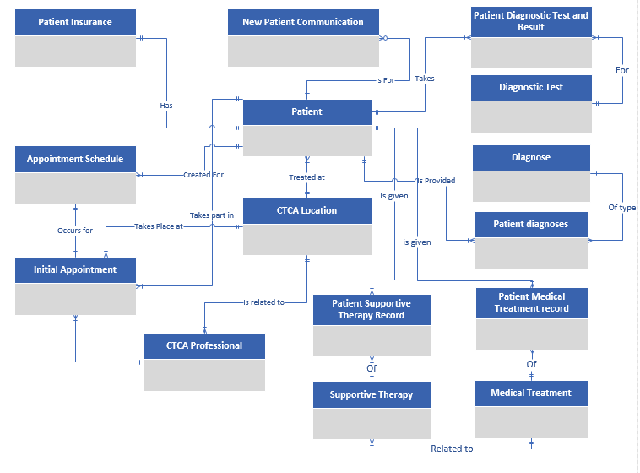

* Logical ERD or EERD.

Logical ERD developed with TOAD Data Modeler tool.

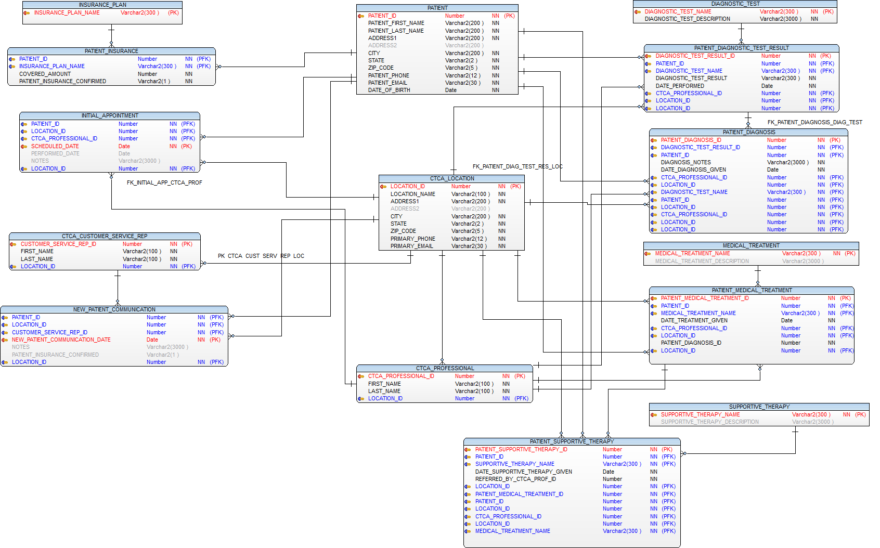

* Test Patient created

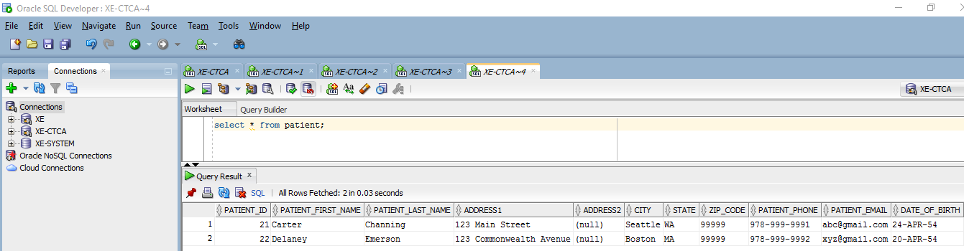

* Insurance Plan created

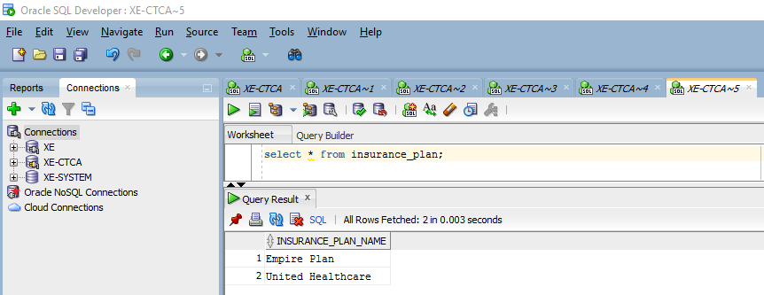

* Patient Insurance

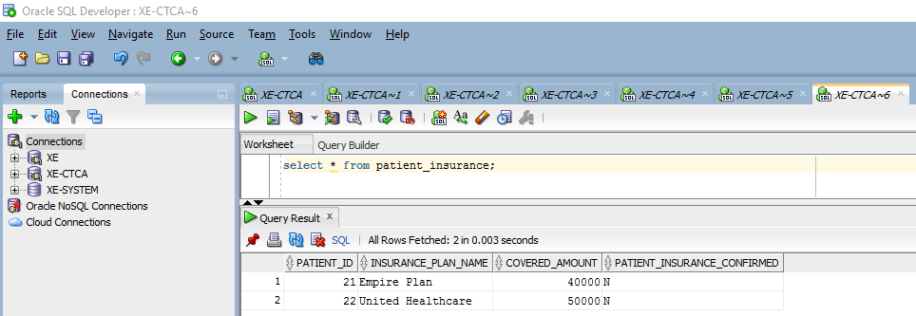

* Location created

[Screenshot removed]

* Professional created

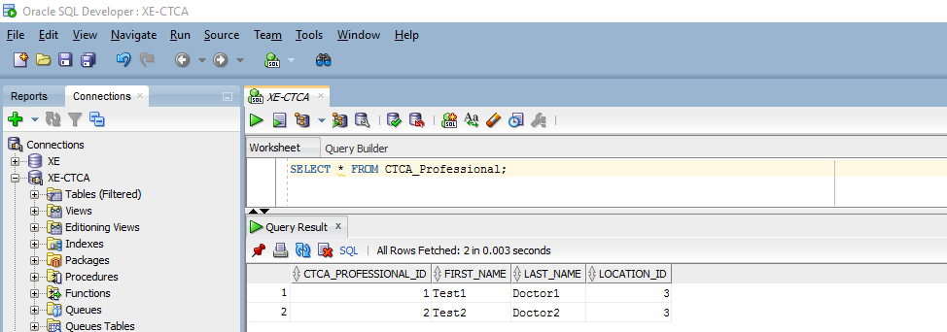

* Initial Appointment created

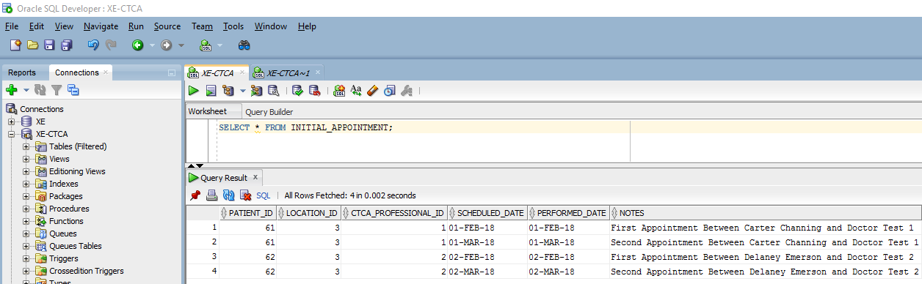

* Diagnostic Tests created

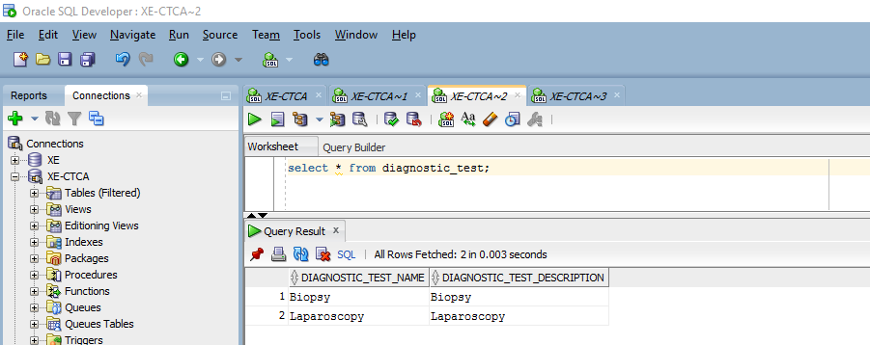

* Diagnostic Test results created

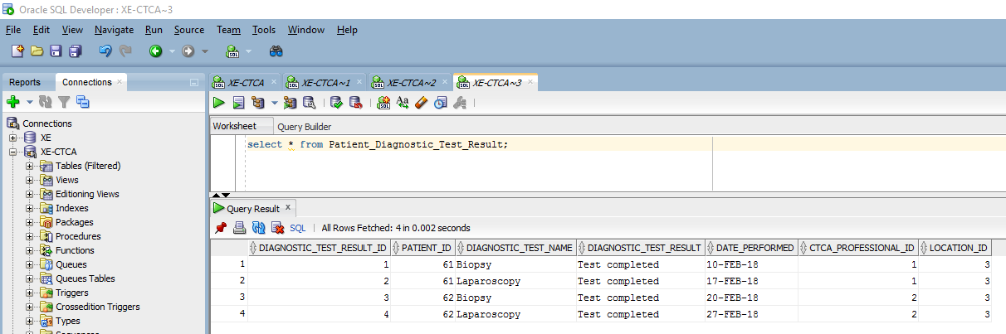

* Record in Medical Diagnosis

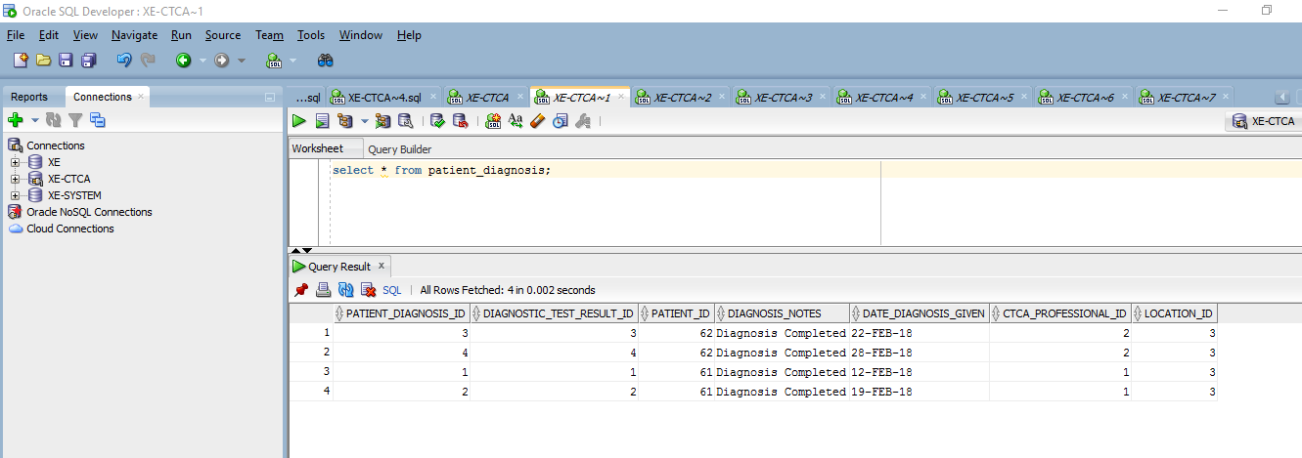

* Medical Treatment created

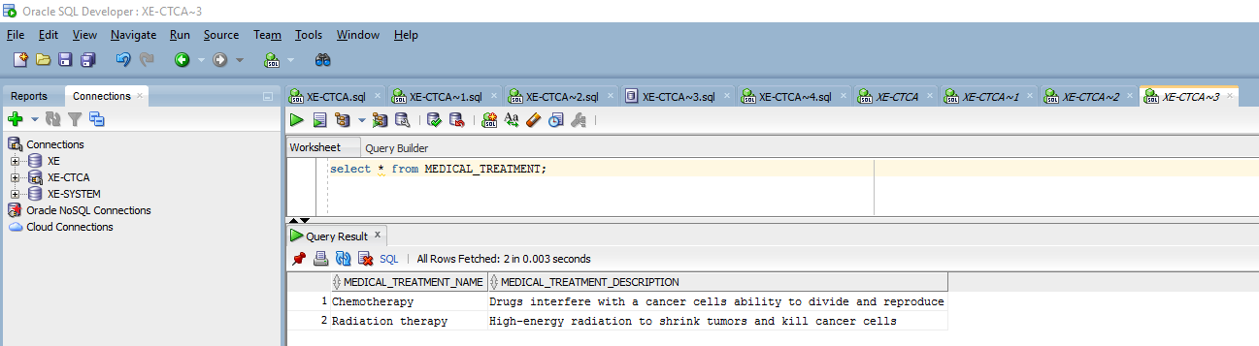

* Patient Medical treatment record created

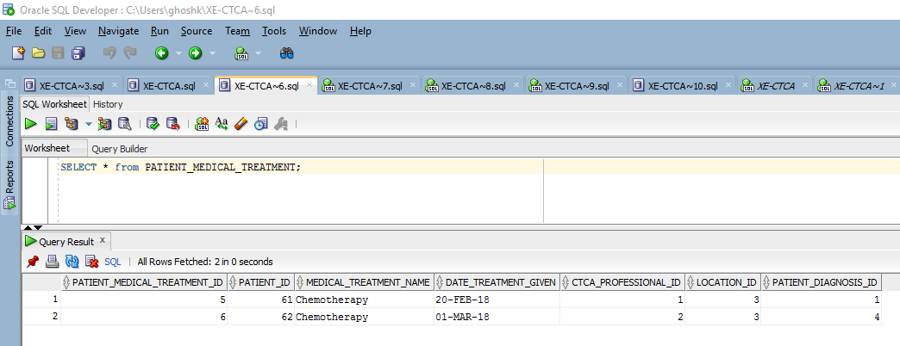

* Created Supportive Therapy

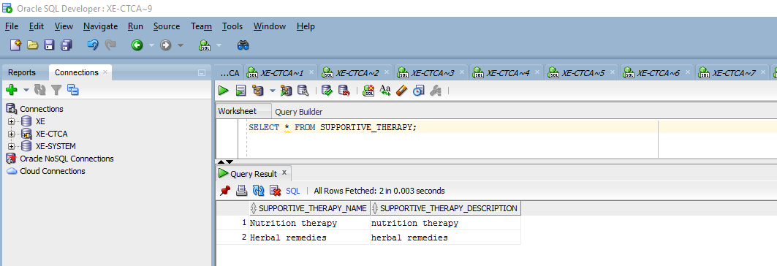’

* Created Patient Supportive Therapy

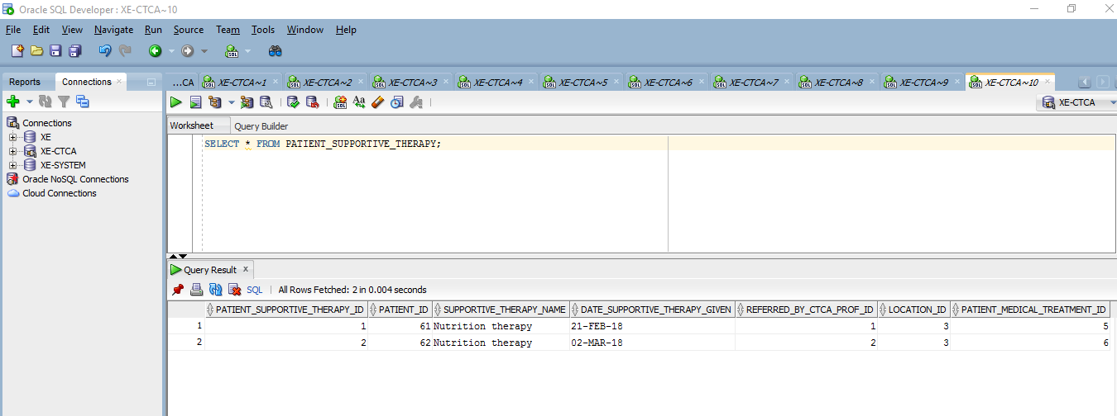

* Screenshot illustrating the creation of the index for performance improvement.

1. Create Unique Index in Patient on columns Patient First Name , Last Name, Patient phone number, patient date of birth. This will help in fetching patient details in all places where we are getting Patient reference based on the combination of the four attributes.

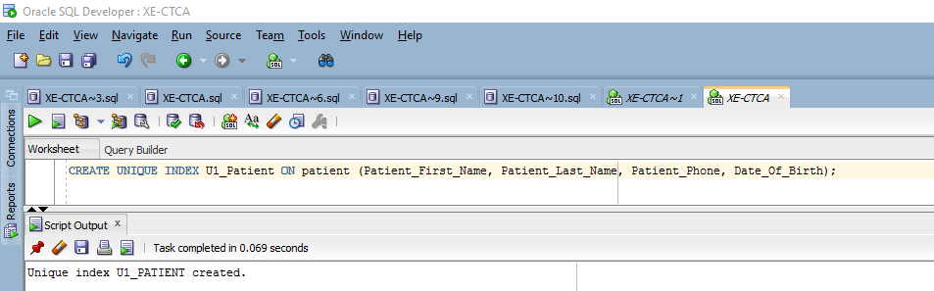

1. Create unique Index on CTCA_Professional table on First Name, Last Name and Location Id. This will fetch CTCA Professional reference faster in all places where we have used it.

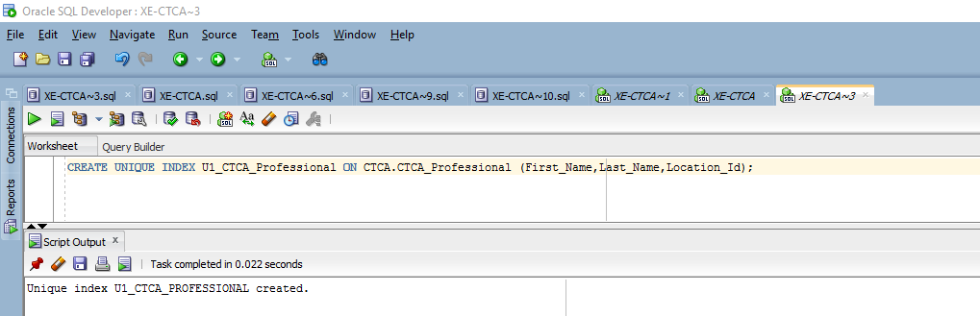

1. Create Index on Patient Diagnostic test result on Patient_Id, Diagnostic_Test_Name, Date_Performed, CTCA_Professional_Id, Location_Id to make search queries work faster on Patient diagnostic test table.

Also an Index on patient Id will help in searching records for a patient.

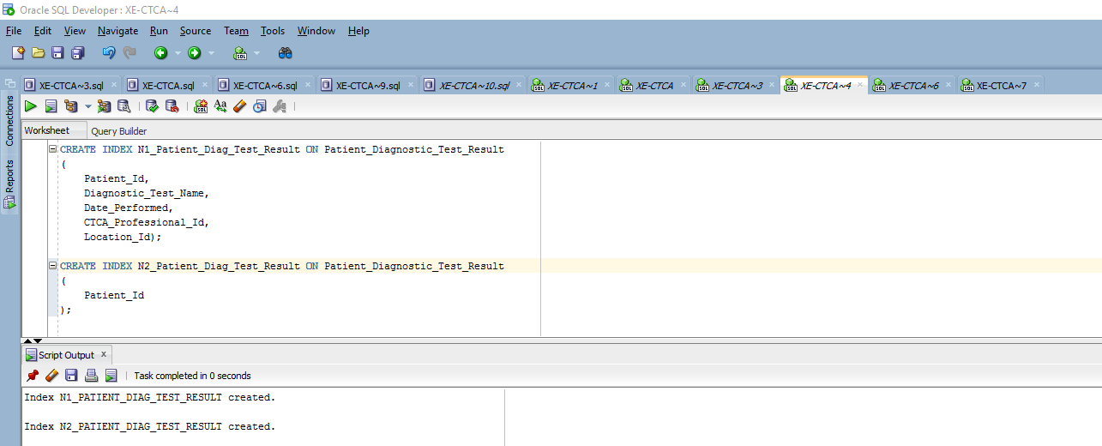

1. CREATE INDEX ON Patient Medical Treatment on (Patient_Id, Medical_Treatment_Name, Date_Treatment_Given, CTCA_Professional_Id, Location_Id, Patient_Diagnosis_Id). This will help get access to patient medical treatment record from any queries performed on it.

Also an Index on patient Id will help in searching records for a patient.

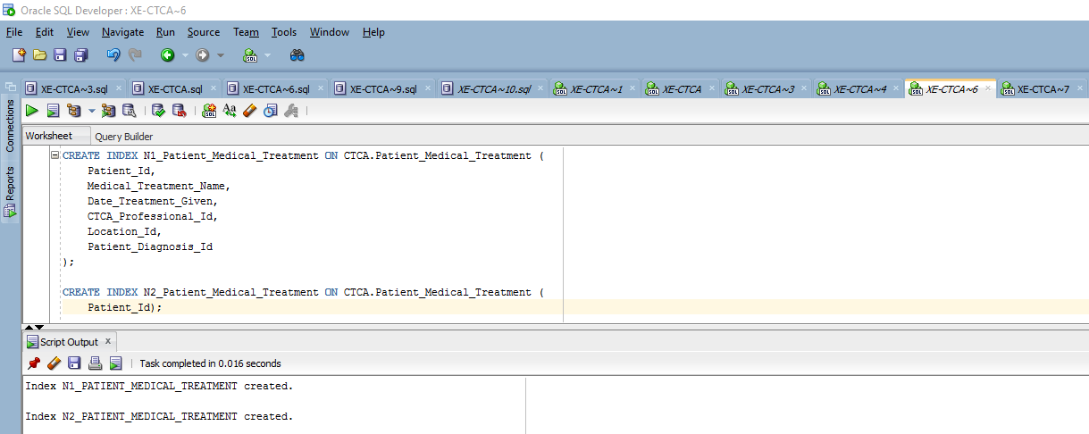

1. CREATE INDEX ON Patient Supportive therapy on (Patient_Id, Supportive_Therapy_Name, Date_Supportive_Therapy_Given, CTCA_Professional_Id, Location_Id, Patient_Medical_Treatment_Id). This will help get access to patient supportive therapy record from any queries performed on it.

Also an Index on patient Id will help in searching records for a patient.

